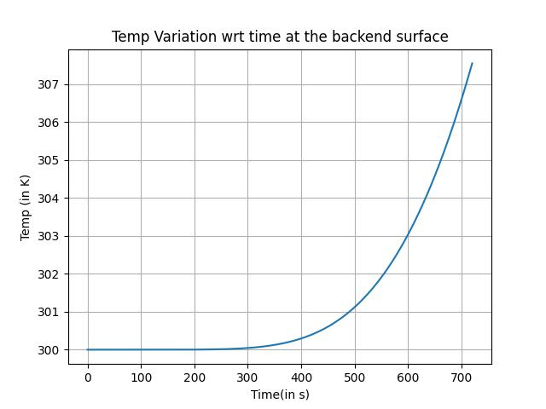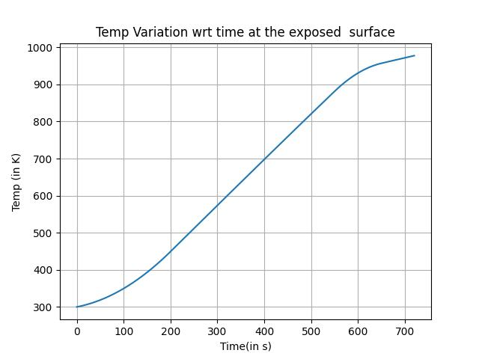

Reinforced Carbon Carbon as material:

Rho = 1600 kg/m3

Cp = 500 J/kg-K

K = 1 W/m-K

Melting Point = 2200 deg Celsius

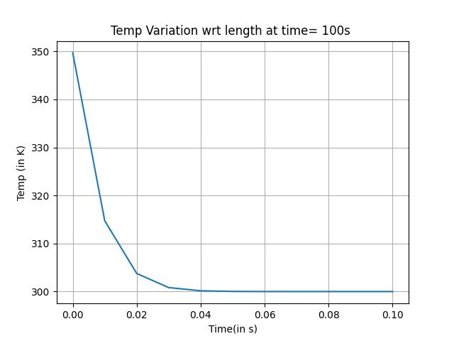

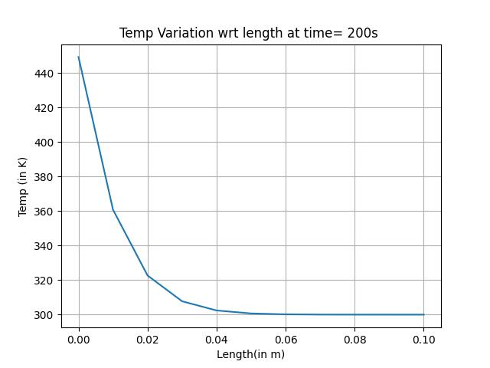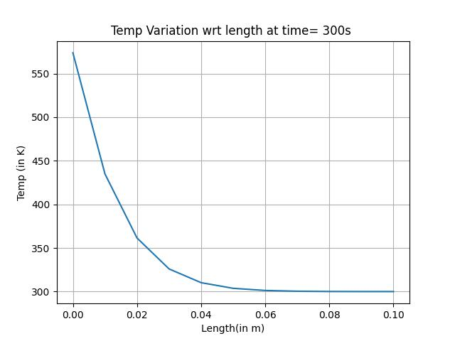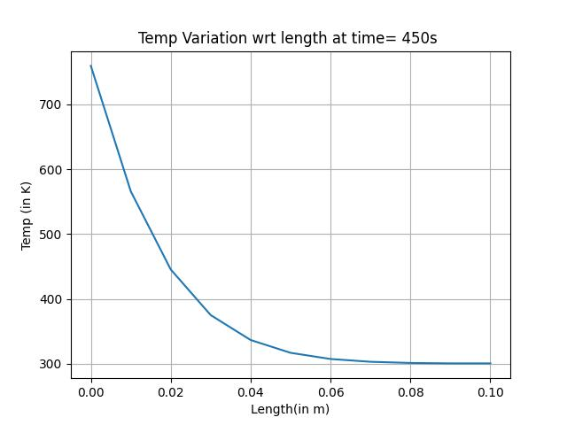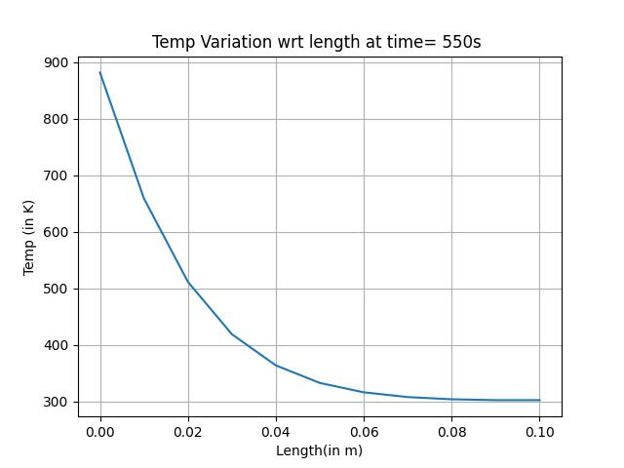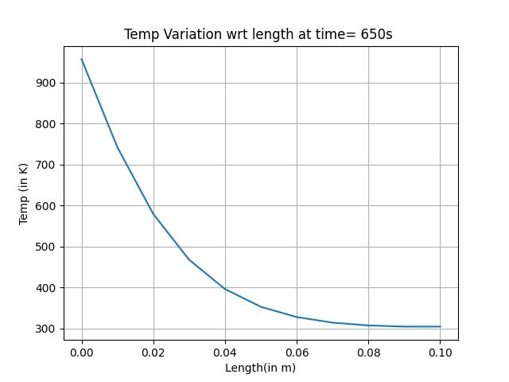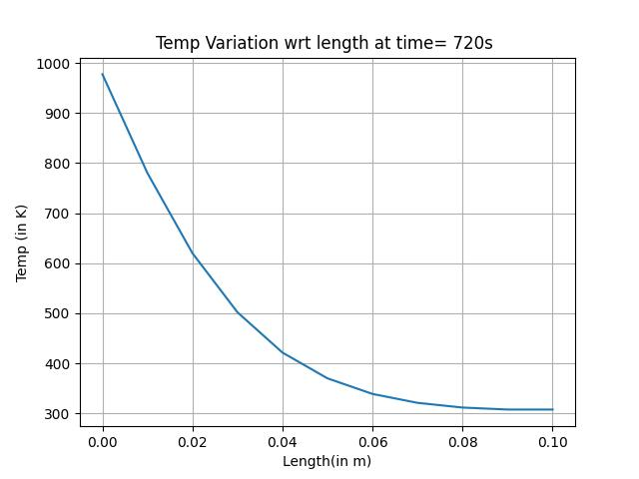

“References used for Material Used”

* Reinforced Carbon-Carbon for High-Temperature Aerospace Structures," by M.K. Ferber and J.T. Carswell. Journal of Spacecraft and Rockets, Vol. 46, No. 2, March-April 2009, pp. 309-320.
* "Thermal Conductivity of Reinforced Carbon-Carbon and Carbon-Silicon Carbide Composites," by A.A. Antipov et al. Journal of Engineering Physics and Thermophysics, Vol. 90, No. 6, November 2017, pp. 1328-1334.
* "Specific Heat Capacity of Carbon-Carbon Composites," by K.N. Chang et al. Journal of Materials Science, Vol. 32, No. 4, February 1997, pp. 891-895.
* "The Density of Carbon-Carbon Composites," by H. Tsuchiya et al. Carbon, Vol. 40, No. 14, December 2002, pp. 2683-2690.